# 2.1 Bar Charts and Pie Charts

Barplot()

* Main = “TITLE”
* Xlab = “x”
* Ylab = “y”
* Las= 1 🡪 rotates the variable to be horizontal on y axises.
* Names.arg=c(“Khaled”, “Amjad”) 🡪 to set the names that u want to appear under the plots.
* Horiz= T 🡪 rotates the chart

N0TE: u need to make changes on y,x(lab).

* Y,x(lim) =c(n1,n2) 🡪 u can sit a limit.

Pie()

# 2.2 Boxplots and Grouped Boxplots

The same properties that was applied to barplot can be applies here.

# 2.3 Box Plots with Two Factors (Stratified Boxplots)

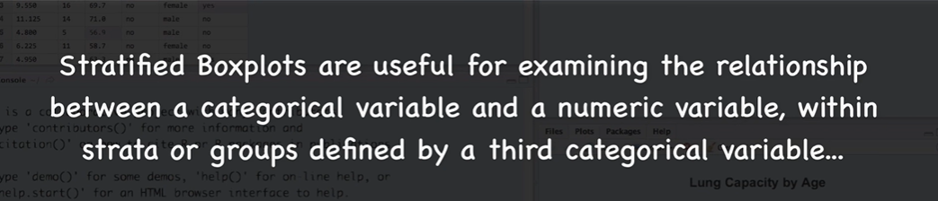

Ex.

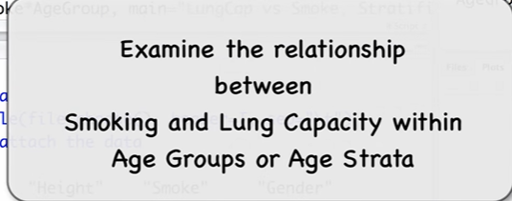

#Create the age groups

AgeGroubs <- cut(Age, breaks=c(0,13,15,17,18), labels = c(“>13”,”14\15”,”16\17”,”18+”))

#check the first 5 Age, and AgeGroubs.

Age[1:5]

AgeGroub[1:5]

String right?

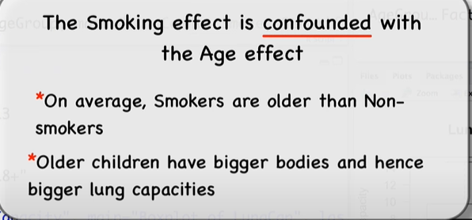

So that will lead us to consider the Age factor

Now seems more reasonable.

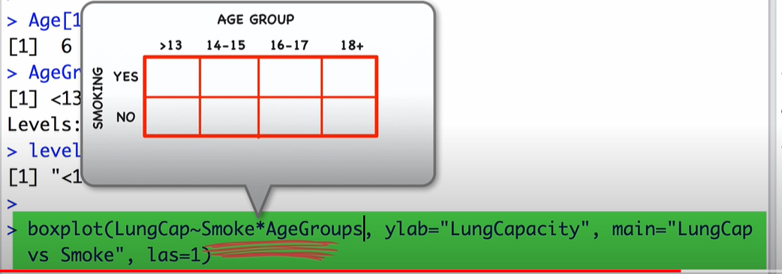

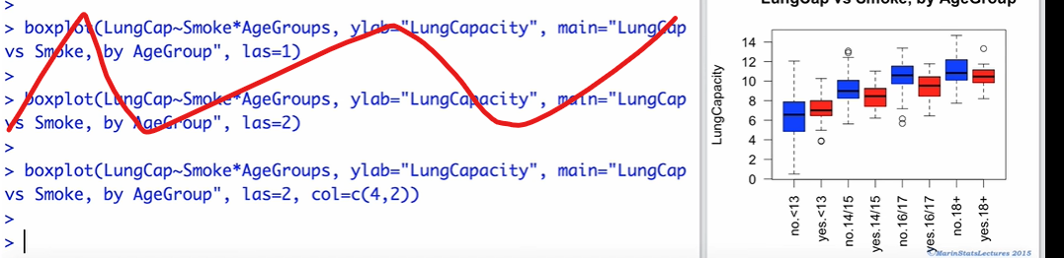

# 2.4 Histograms in R

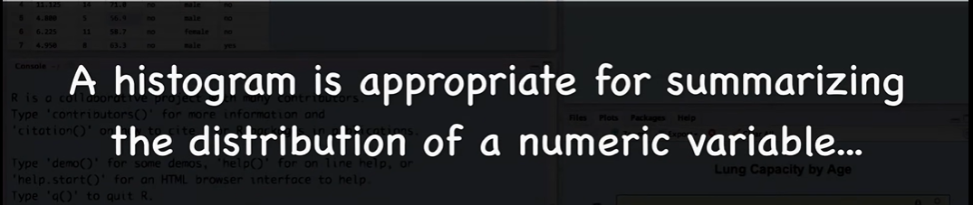

Hist()

To change the frequency on the y axis u can use one of the following:

* Freq = F
* Prob = T

U can change the # of bars by using *breaks*

*Ex. hist(LungCap, prob = T, col=c(4,2), breaks = 6)*

Lines(density(LungCap*), lwd=3 ) 🡪 To Add density curve, lwd for density of the line

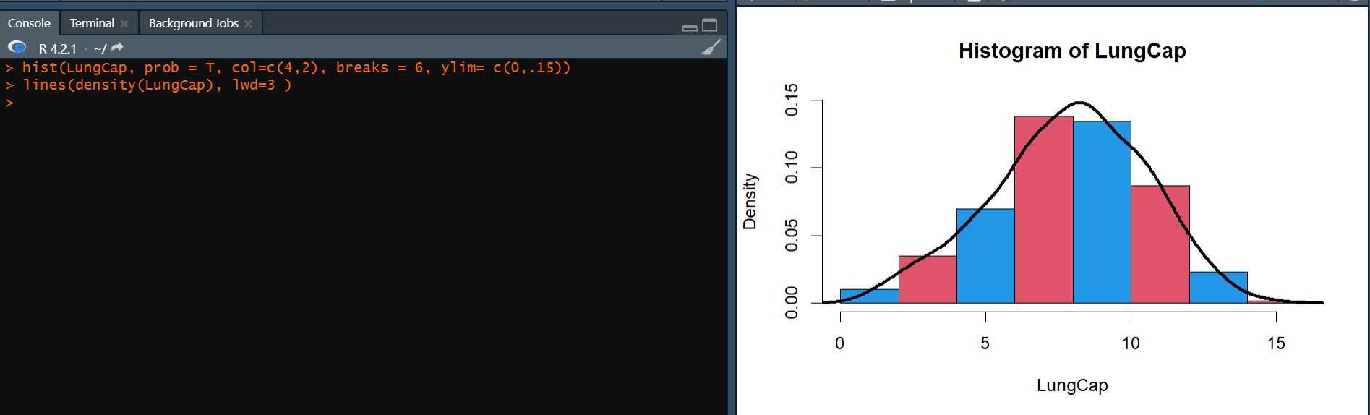

# 2.5 Stem and Leaf Plots

